Wa-Tor Speed-up Report

Run on a 12th Gen Intel Core i7-1260P, with 12 cores (4 performance cores and 8 efficiency cores) and 16 threads.
10 tests were completed per thread amount, on a grid of size 1000 x 1000 pixels. The Wa-Tor graphics were disabled to allow for a significant speed-up to occur. The grid was populated with 30000 fish and 3000 sharks, with a fish breed time of 3 chronons, shark breed time of 10 chronons and shark starvation time of 4 chronons. Each test was run for a total of 500 chronons.
The project was parallelised by adding #pragma omp parallel num_threads(num of threads to be used) around the main body of code that updates each square in the grid. The grid is tiled for this process by dividing the y dimension of the grid by the number of threads being used. Each tile leaves their first row untouched initially, as these rows may overlap with each other when updating in parallel, causing them to update incorrectly.
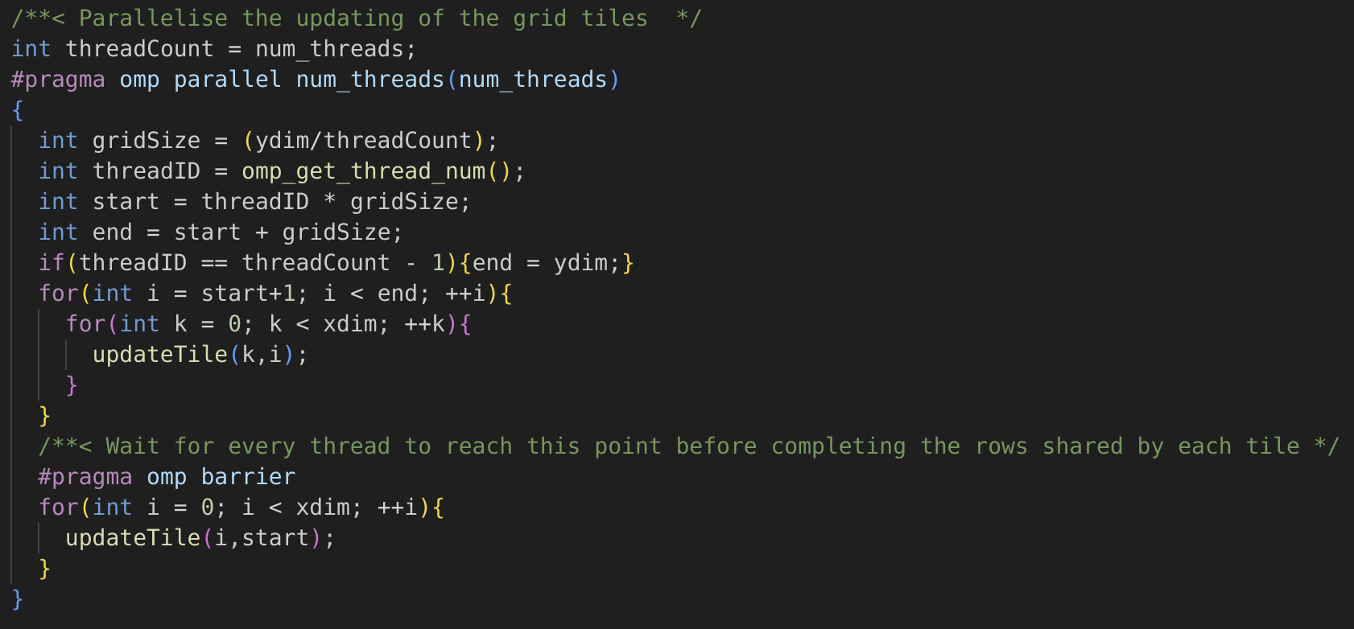
These remaining rows are completed after each thread reaches a barrier, ensuring that no two threads are updating their connecting rows at the same time.

One Thread:
Slowest – 64.003570 seconds
Fastest – 59.333477 seconds
Average – 60.9592472 seconds
Two Threads:
Slowest – 43.935010 seconds
Fastest – 40.091455 seconds
Average – 41.1158654 seconds

Four Threads:
Slowest – 33.507065 seconds
Fastest – 31.677157 seconds
Average – 32.3871408 seconds

Eight Threads:
Slowest – 37.002510 seconds
Fastest – 36.061277 seconds
Average – 36.5953036 seconds
Sixteen Threads:
Slowest – 38.502207 seconds
Fastest – 37.407232 seconds
Average – 37.8119273 seconds

Significant speed-up occured from the use of one thread to the use of four threads, with a roughly 18 second speed up. This is the expected outcome from a grid of the size utilised. The execution speed slowed down when increasing to eight and sixteen threads, presumably as a result of the overhead involved from this amount of threads on a grid that was not large enough. As the largest possible grid that I could create, which was 2000 x 2000, still resulted in a slower execution speed at these threads, I opted for a better middleground grid size for testing. The average speed-up per threads used is graphed below, with error bars included.

